# UI Demo

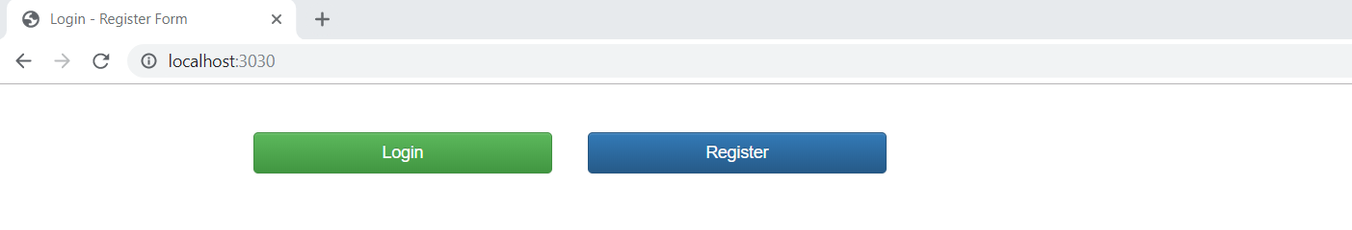

Login Page:

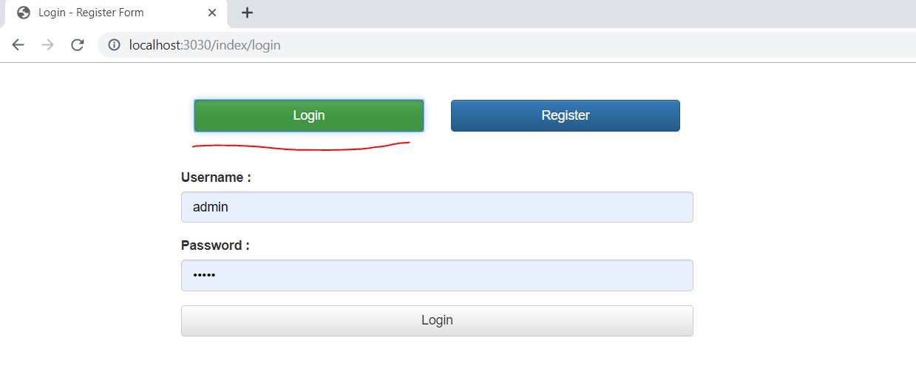

Username- admin

Password- admin

Admin View:

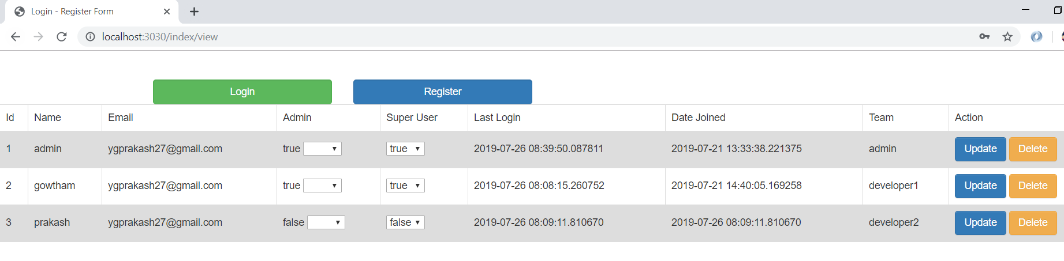

Developer Login:

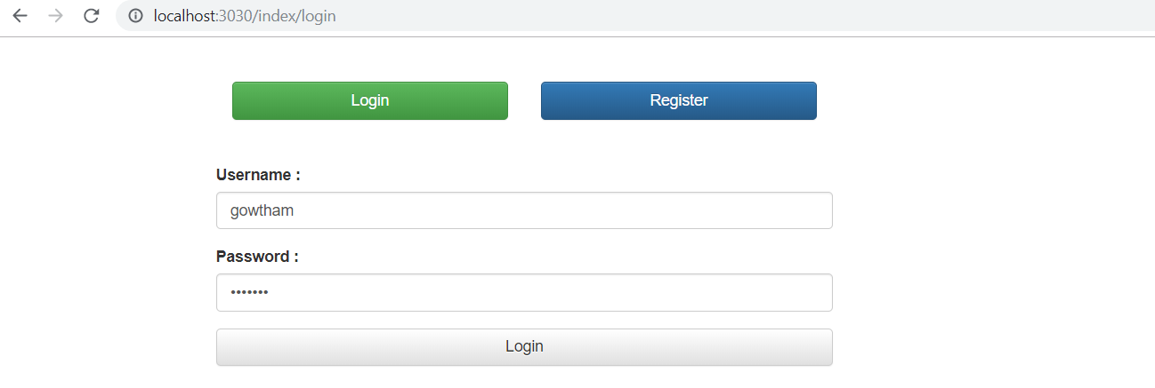

Developer View:

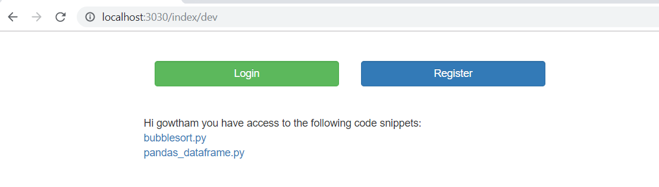

Clickable links to view code snippet for the code snippets developer has access to:-

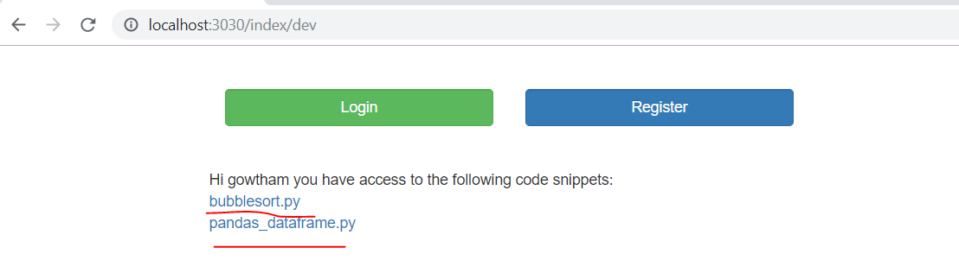

Code snippet view:

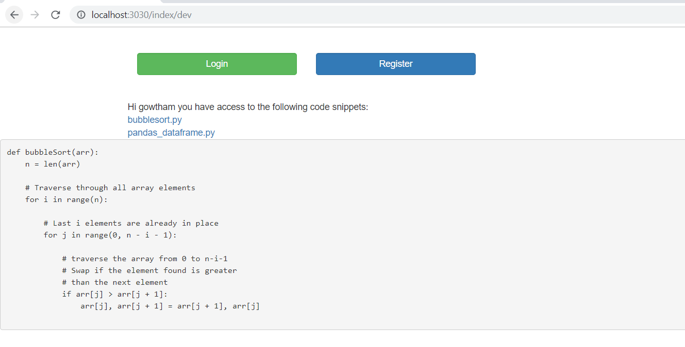

Registration Form:

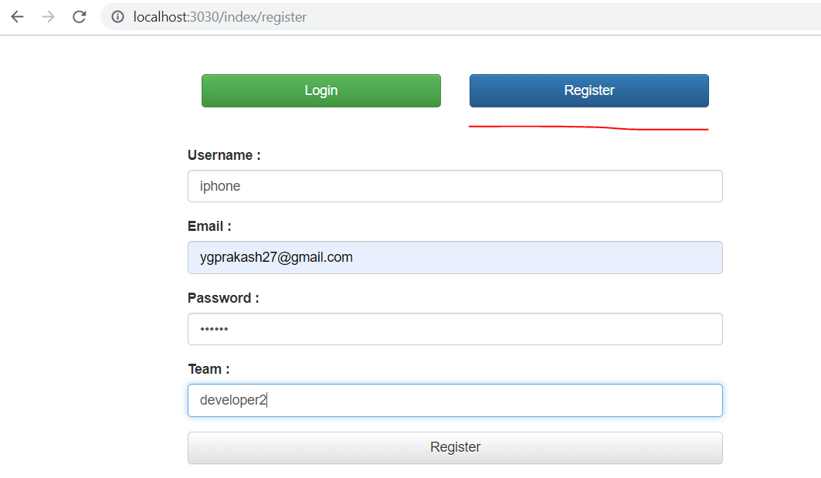

Registration success page:

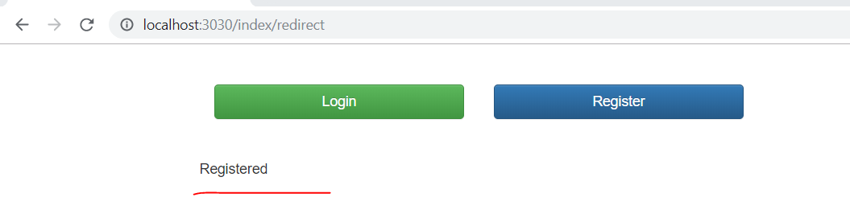

Invalid User Login:

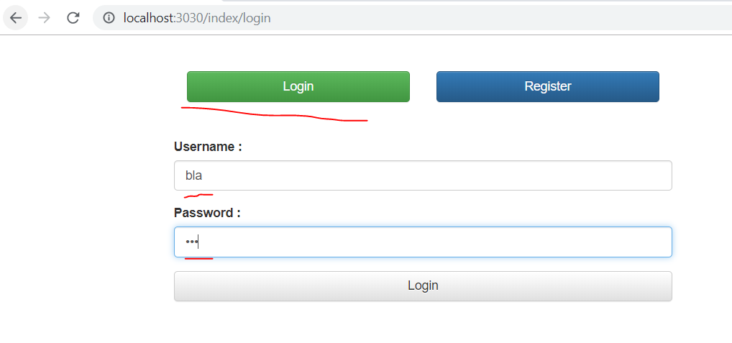

Unauthorized user Response:

